The Morning Call/
Muhlenberg College Institute of Public Opinion

Public Perceptions of
The Pennsylvania Budget Situation

KEY FINDINGS REPORT

Release Date March 6, 2011

KEY FINDINGS:
- Pennsylvanians overwhelmingly see the budget situation in Harrisburg as a serious problem facing the Commonwealth.

- State residents expressed skepticism regarding Governor’s Corbett’s ability to meet his pledge to not raise taxes or fees as a means of addressing the state’s budget deficit.

- Keystone State residents are generally supportive of selling Pennsylvania’s liquor stores as a means of producing revenue for the state.

- A solid majority of the Commonwealth’s citizens support a tax on the extraction of natural gas from the state’s Marcellus shale deposits.

- Most residents of the state oppose the leasing of the Pennsylvania Turnpike to a private company.

- Pennsylvanians are willing to pay higher driver’s license and motor vehicle registration fees if the revenue generated from such means is used for repair and maintenance of the state’s transportation system

METHODOLOGY: The following key findings report summarizes data collected in a telephone survey of residents of the state of Pennsylvania between February 9 and February 28, 2011. Individual households and cell phones throughout Pennsylvania were selected randomly for inclusion in the study. The sample of phone numbers used in the survey was generated by Genesys Sampling Systems of Ft. Washington, PA. Interviewing was conducted by the staff of the Muhlenberg College Institute of Public Opinion, with 471 surveys completed. This number of completions results in a margin of error of +/- 4.5% at the 95% confidence interval. However the margin of errors for sub groups (i.e. women, income groups, age categories) is larger due to smaller sample size. Percentages throughout the survey have been rounded upward at the .5 mark, thus many totals in the results will not equal 100%. The data has been weighted by the following categories: age, gender, educational attainment, race and region. The instrument was designed by Christopher Borick, Ph.D and Katherine Sharga of the Muhlenberg College Institute of Public Opinion in consultation with staff members of the Morning Call. The analysis was written by Katherine Sharga, Assistant Director of the MCIPO and Dr. Borick.

OVERVIEW:
As Pennsylvania’s newly-elected governor Tom Corbett prepares to deliver his first budget address to the citizens of Pennsylvania, the state government’s fiscal picture appears very ominous with a $4-5 billion budget deficit looming. In this project we explore the views of Pennsylvanians on the budget situation in Harrisburg, with a focus on citizen perception of the scope of the crisis, the options for solving the crisis and the Governor’s role in leading Pennsylvania through the fiscal difficulties that the state is enmeshed in.

PERCEPTIONS OF THE FISCAL SITUATION in PENNSYLVANIA:
While considering Pennsylvania’s current fiscal condition, an overwhelming majority of respondents said that the budget problems are serious. Only 6% of Pennsylvania residents believe that the state’s fiscal problems are not serious, with nearly half (46%) describing the fiscal problems as very serious.
FIGURE ONE

How serious do you think Pennsylvania's budget problems are? Would you say they are very serious, somewhat serious, not too serious, or not at all serious?

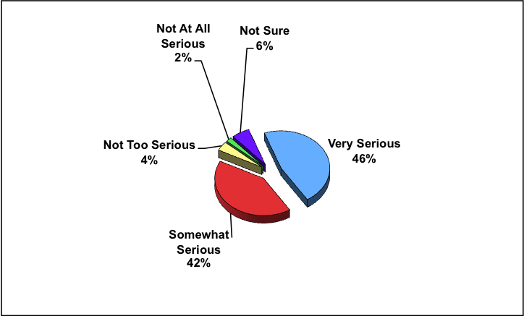
Source: MCIPO 2011

With a general acceptance among Commonwealth residents regarding the serious nature of the budget problems in Harrisburg it is important to understand the public’s preferences for addressing the matter. The survey results show Pennsylvanians to have a diverse array of opinions on the best approach to take to solve the fiscal difficulties the state is experiencing and a variety of views on the particular policy options available in this matter.

From a broad perspective Pennsylvanians see cutting services as a more acceptable option than increasing taxes in terms of balancing the state budget. More specifically, by a 2 to 1 margin residents of the Keystone State would support cutting government services over raising taxes as a means of bringing the state’s fiscal house in order.

TABLE ONE

“To balance the state budget, if you had to choose, would you prefer- raising taxes or cutting government programs and services?”

Policy Approach | Percent Responding
Raising Taxes | 23%
Cutting Services | 50%
Other | 11%
Not Sure/Refused | 16%
Source: MCIPO 2011
The views on which broad action (i.e. taxes vs. cuts) is more preferable in balancing the state budget vary across the gender of state residents. The survey findings indicate males were willing to cut government programs and services than their female counterparts, with 59% of men saying this would be their choice compared to 45% of women.
TABLE THREE
Preferences for Approaches to Balance the State Budget
By Gender of Respondent

 | Raise Taxes | Cut Government Programs and Services | Other | Not Sure
Male | 21% | 59% | 11% | 4%
Female | 25% | 45% | 11% | 15%
Source: MCIPO 2011

As might be expected given the ideological differences found among individuals from different political parties, Democrats and Republicans view the broad approaches to deal with the budget problem quite differently. While Democrats were split between the cutting of programs and services (35%) and raising taxes (35%), Republicans and independents overwhelmingly favored spending cuts over increased taxes as the best way to a balanced budget

FIGURE TWO
Preferences for Approaches to Balance the State Budget
By Party Affiliation of Respondent

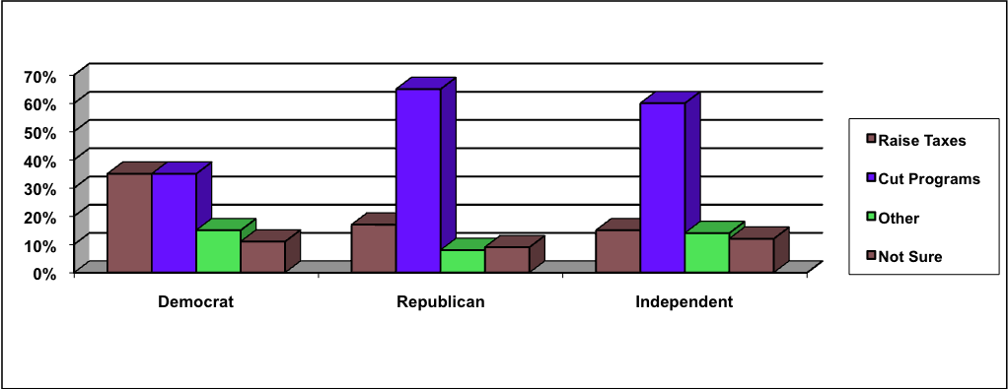Source: MCIPO 2011

PERSPECTIVES on GOVERNOR CORBETT and the BUDGET CRISIS

As the new governor of the Commonwealth Tom Corbett’s standing in the state will be affected by his ability to address the budget issues in Harrisburg. During the campaign in 2010 Corbett made fiscal conservatism a cornerstone of his election platform. In that campaign Corbett pledged that he would not raise taxes or fees as means of balancing the state budget. While Corbett’s position on this matter aligns nicely with the data from earlier in the report that showed little public support for using tax increases to balance the budget, it has been argued that his pledge may limit the range of fiscal options available to him as he confronts the budget situation. According to the results of this study Pennsylvanians are fairly evenly divided on whether or not Corbett should have made this pledge. As can be seen in Table Three, 43% of those surveyed said Governor Corbett should have made that pledge, while 39% do not think the pledge was advisable.

TABLE THREE

“Governor Tom Corbett has pledged that in trying to balance the state's budget deficit he will not raise taxes or fees. Do you think Gov. Corbett should have made this pledge?”

Position | Percent
Yes | 43%
No | 39%
Not Sure/Refused | 18%

Source: MCIPO 2011

While Pennsylvanians are split on the wisdom of Tom Corbett’s pledge to not raise fees or taxes as a means of balancing the state budget, they lean to the belief that he will not be able to keep this promise. By a 2 to 1 margin Pennsylvanians believe that the state’s chief executive will be unable to hold to his pledge to not raise taxes or fees in the Keystone State.

FIGURE THREE

“Do you think Tom Corbett will be able to keep his campaign pledge or not?”

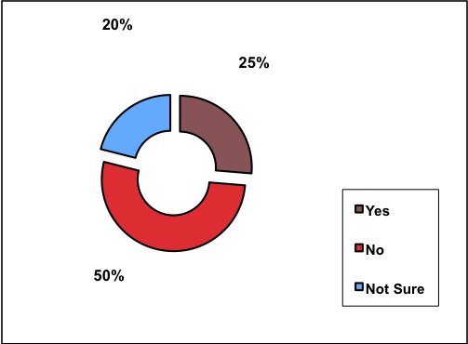
. Source: MCIPO 2011
PUBLIC SUPPORT FOR REVENUE ENHANCEMENT OPTIONS
With Governor Corbett’s pledge to not raise taxes and fees and the public’s general opposition to raising taxes as a mechanism to balance the state budget, other options are being considered as a means of enhancing the state’s revenue sources. Among the options being discussed are: (1) selling the state-owned liquor stores; (2) leasing the Pennsylvania Turnpike; and (3) placing a tax on the extraction of natural gas from the state’s Marcellus shale deposits. The results show mixed public support for these policy options.

The revenue generation option that is most popular among the public is the sale of Pennsylvania’s publically owned liquor stores, with a tax on natural gas drilling drawing similarly high levels of public support. Conversely, more Keystone State residents oppose the leasing of the Pennsylvania Turnpike as a means to raise revenue for the state.

FIGURE FOUR

Public Support for Various Revenue Generation Options

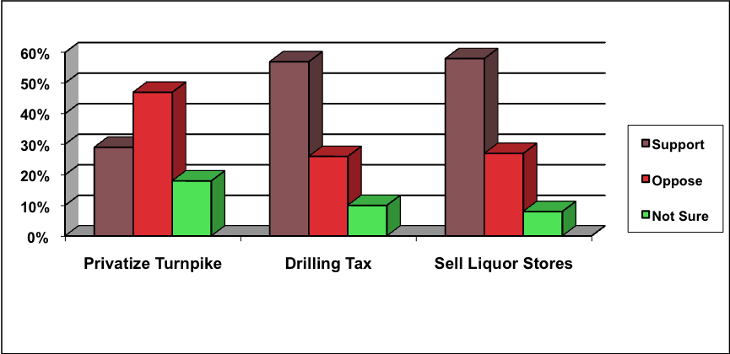
Source: MCIPO 2011
A majority of Pennsylvania residents said they would support the sale of state-owned liquor stores to help balance the budget, with only about a quarter of state residents opposed to the idea. When looking at the sale of state-owned liquor stores, the opposition was highest among lower-income Pennsylvanians (37%), with only 21% of middle-income and 12% of high-income residents opposed to this option. A majority of both Democrats and Republicans support the sale of the state liquor stores with 65% of Republicans and 54% of Democrats (54%) in favor of selling the stores to help balance the state budget.

TABLE FOUR

Views on the Sale of State-owned Liquor Stores
By Income Level and Party Affiliation

 | Strongly Support | Somewhat Support | Somewhat Oppose | Strongly Oppose | Not Sure
Under $40K | 28% | 25% | 16% | 21% | 9%
$40-80K | 46% | 26% | 6% | 15% | 6%
Over $80K | 54% | 29% | 4% | 8% | 6%
Democrat | 31% | 23% | 13% | 19% | 8%
Republican | 41% | 24% | 10% | 16% | 7%
Independent | 40% | 25% | 10% | 8% | 12%

Another possibility for decreasing the state’s budget deficit lies in natural gas. During recent years there has been an increased level of natural gas drilling of Pennsylvania's Marcellus shale deposits. Currently there is no tax on the extraction of natural gas in the state. When asked if companies should be taxed for natural gas drilling in Pennsylvania, 57% of those surveyed said they would support such legislation, with only 26% opposed to this method for generating revenue for the state.

TABLE FIVE

Support for a Tax on Natural Gas Extraction in Pennsylvania

Position | Percent
Strongly Support | 34%
Somewhat Support | 23%
Somewhat Oppose | 12%
Strongly Oppose | 14%
Not Sure/Refused | 17%

There is a moderate difference in viewpoints on a natural gas extraction tax when the survey respondent’s party affiliation is considered. While a majority of Democrats, Republicans and independents support a natural gas extraction tax, Pennsylvania Democrats are most supportive of the option and state Republicans most likely to oppose the proposal.

TABLE SIX

Marcellus Shale Extraction Tax (By Party Affiliation)

 | Strongly Support | Somewhat Support | Somewhat Oppose | Strongly Oppose | Not Sure
Democrat | 39% | 26% | 8% | 11% | 11%
Republican | 30% | 24% | 18% | 17% | 9%
Independent | 40% | 21% | 14% | 17% | 6%
Source: MCIPO 2011

One exception to residents’ willingness to support change was seen in the possibility of leasing the Pennsylvania Turnpike to a private company. Only 29% of Pennsylvania residents said that they would support this endeavor. Opposition for leasing the Pennsylvania turnpike is highest among lower-income level residents with 58% of those making under $40,000/year opposed to the idea, compared to 44% and 42% of the middle and upper-income residents, respectively.

FIGURE FIVE

Views on Leasing the Pennsylvania Turnpike
By Income Level of Respondents

Source: MCIPO 2011

Support for Earmarked Transportation Fee and Tax Increases

The annual Pennsylvania quality of life surveys conducted by The Muhlenberg College Institute of Public Opinion has shown increasingly negative ratings regarding the state’s transportation system. As a result of the budget deficit, the state is also experiencing a shortfall in funds to repair and maintain the state's transportation infrastructure. When asked if they would be willing to pay higher driver’s license and motor vehicle registration fees to improve the state’s transportation system if the money generated went to transportation infrastructure, 53% of residents were supportive while only 31% opposed the option.

FIGURE SIX

Willingness to Pay Higher Driver’s License and Motor Vehicle Registration Fees
If Revenue is Earmarked for Infrastructure Repair

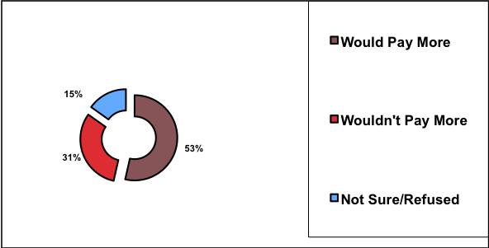

Support for the use of increased motor vehicle related fees as a means of paying for maintenance and repair of Pennsylvania’s transportation network can be found across the state’s ideological divides. At least half of Pennsylvania’s Republicans, Democrats and independents are willing to pay higher motor vehicle fees if the revenue generated bolsters the Commonwealth’s transportation infrastructure. Opposition to this option was highest among Republicans with about 4 out of 10 members of this cohort against this finance mechanism, compared to only 23% of Democrats.
TABLE SEVEN

Pay Higher Fees to Improve State Transportation System (By Party Affiliation)
 | Would Pay More | Would Not Pay More | Not Sure
Democrat | 64% | 23% | 7%
Republican | 50% | 38% | 9%
Independent | 58% | 35% | 6%
Source: MCIPO 2011
CONCLUSION
Pennsylvania’s newly-elected governor, Tom Corbett, faces some serious challenges in his first year as the state’s leader. With a $4-5 billion budget deficit, many things affecting the quality of life for Pennsylvanians, like transportation and government services, are being pushed aside. An overwhelming number of state residents agreed that the deficit is a serious situation that requires immediate attention and possible solutions. When presented with options for reducing the state budget deficit, most residents surveyed were open to changes and even willing to pay additional fees if the monies generated directly benefited the state’s infrastructure.

